CASE STUDY

MODULE – 2

**EC2 , EBS AND EFS**

DONE BY

RANJITH KUMAR

**Tasks To Be Performed:**

1. Create an instance in the US-East-1 (N. Virginia) region with Linux OS and

manage the requirement of web servers of your company using AMI.

2. Replicate the instance in the US-West-2 (Oregon) region.

3. Build two EBS volumes and attach them to the instance in the US-East-1

(N. Virginia) region.

4. Delete one volume after detaching it and extend the size of the other

volume.

5. Take backup of this EBS volume.

1. **Create an instance in the US-East-1 (N. Virginia) region with Linux OS and manage the requirement of web servers of your company using AMI.**

**Step 1** : Logined using IAM user of my aws account.

**Step 2** : Opened EC2 from the aws services.

**Step 3** : Selected **North virginia(US-East-1)** region at the top right corner and click launch instances

**Step 4** : In **Launch an instance** page ,

Name - Linux_Os

AMI - Linux OS

INSTANCE TYPE – T2.micro

KEY PAIR - MY_KP (I Have created a key pair in .ppk format )

NETWORK SETTINGS -default network is chosen.

CONFIGURE STORAGE - 8 Gib (GP3) of root volume is choosen.

**Step 5** : Click launch instance .

x.

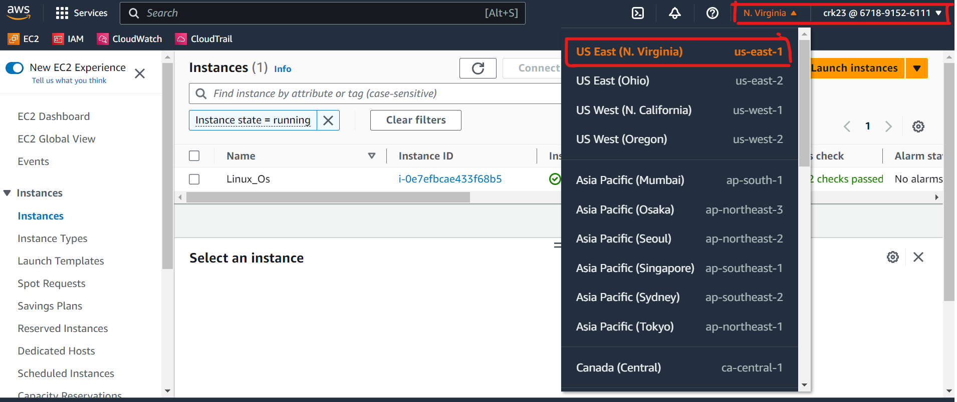



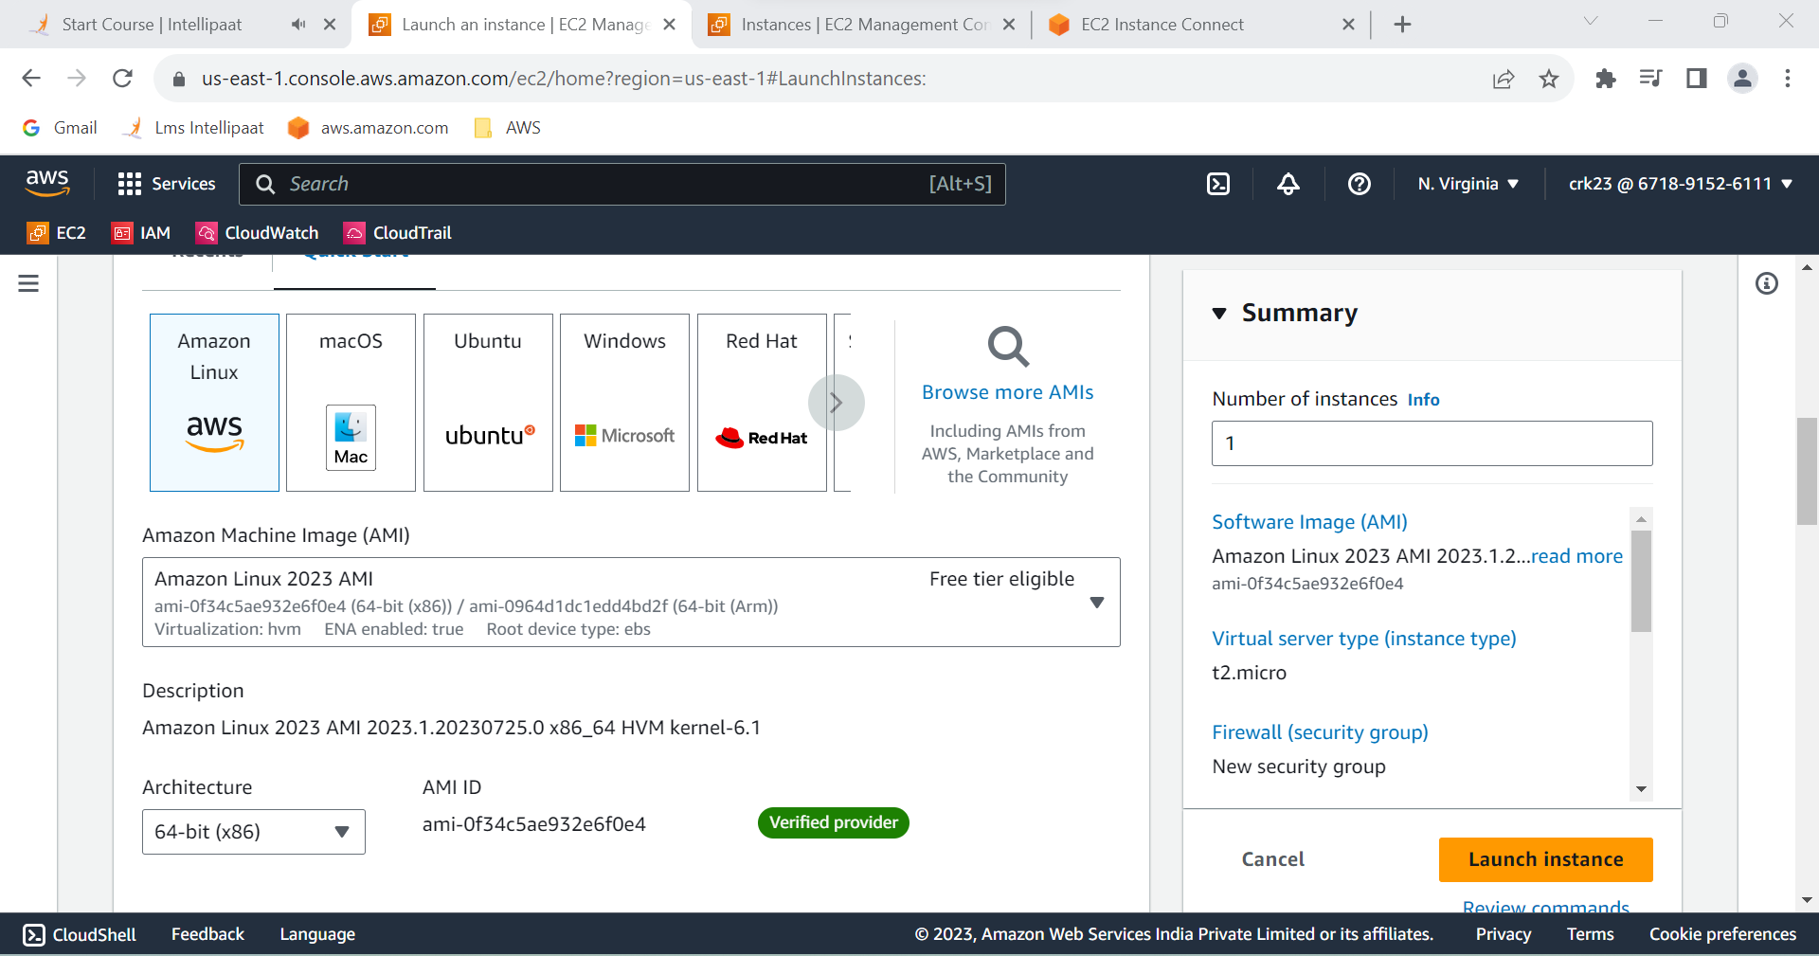

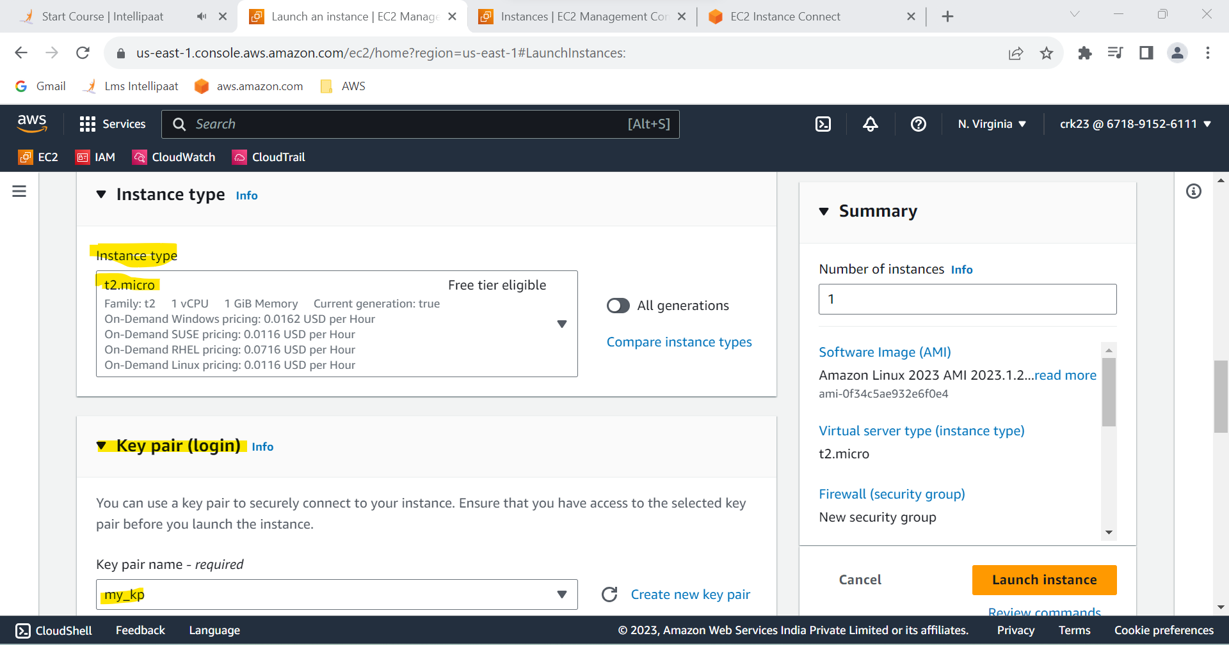

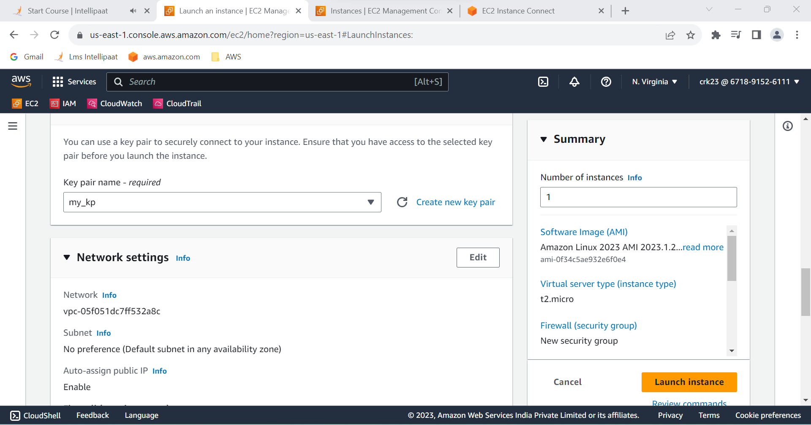

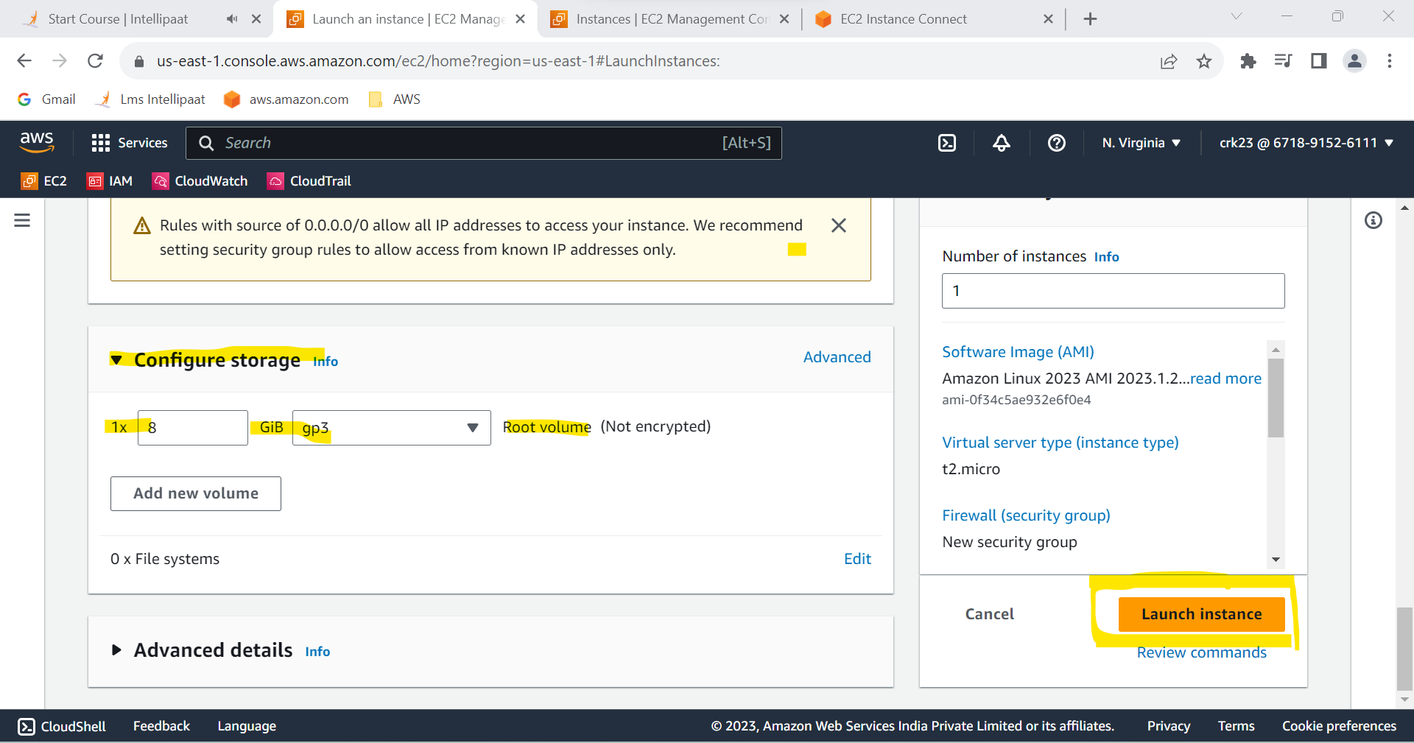

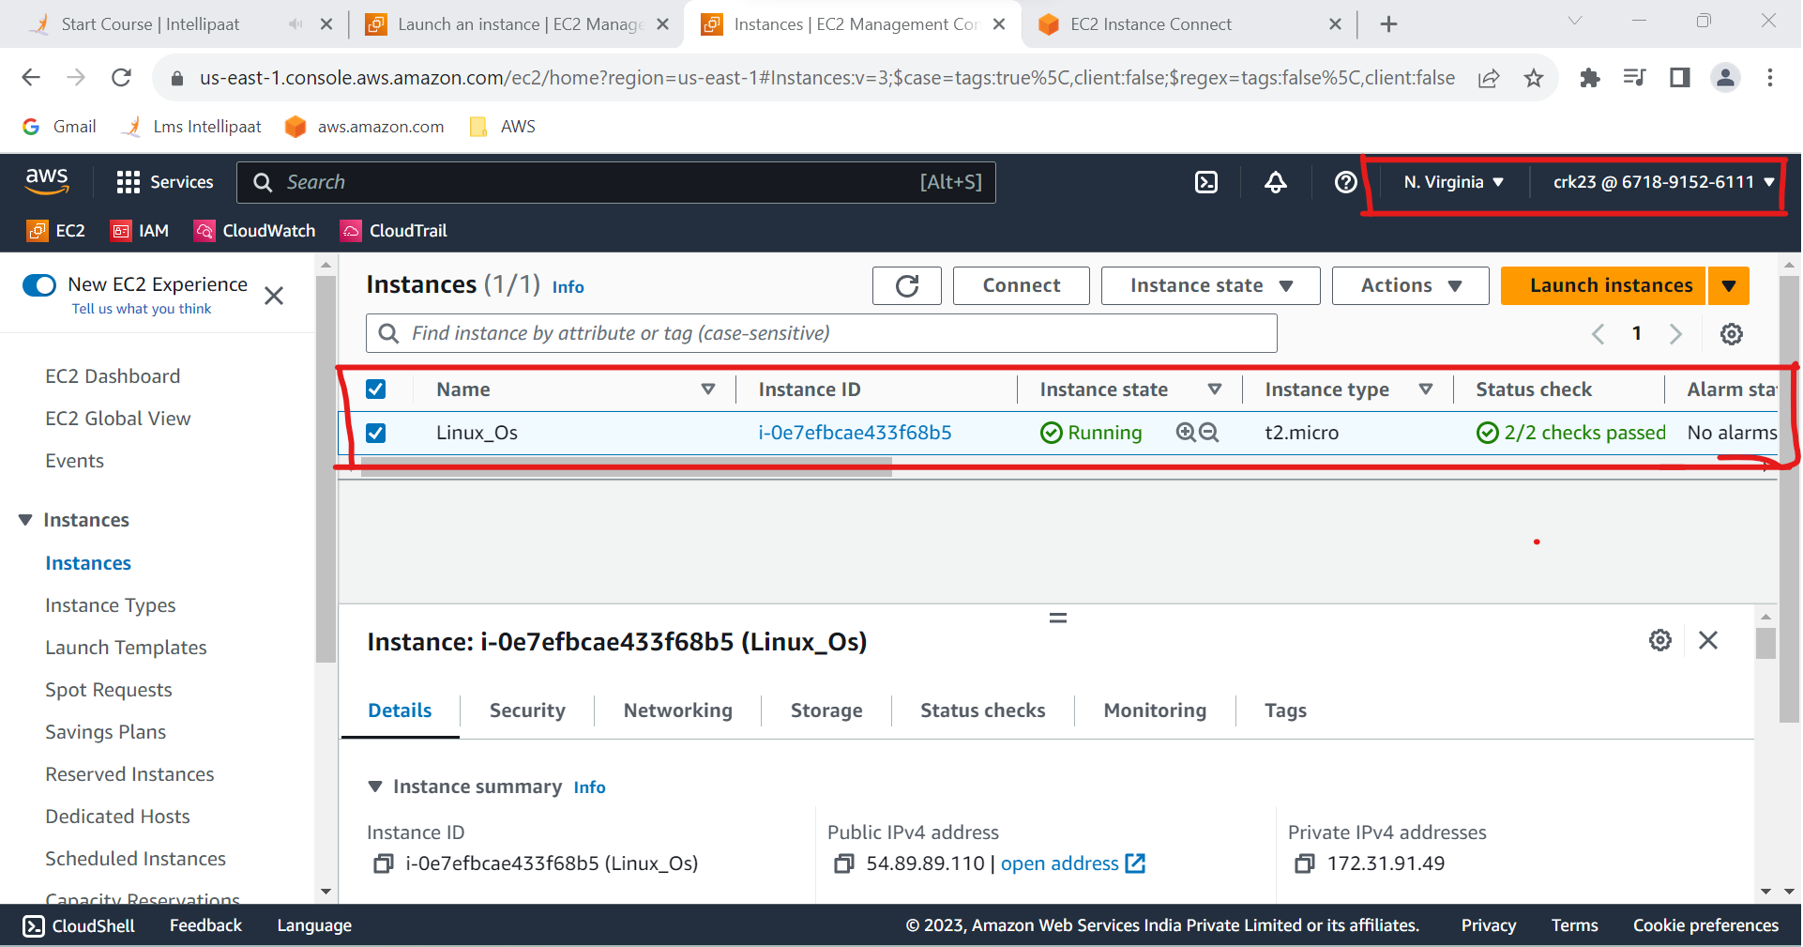

Wecan connect to a instance by various ways such as **EC2 connect,command prompt,putty,poweshell,cloudshell.**

I have used **EC2 instance connect** to connect.

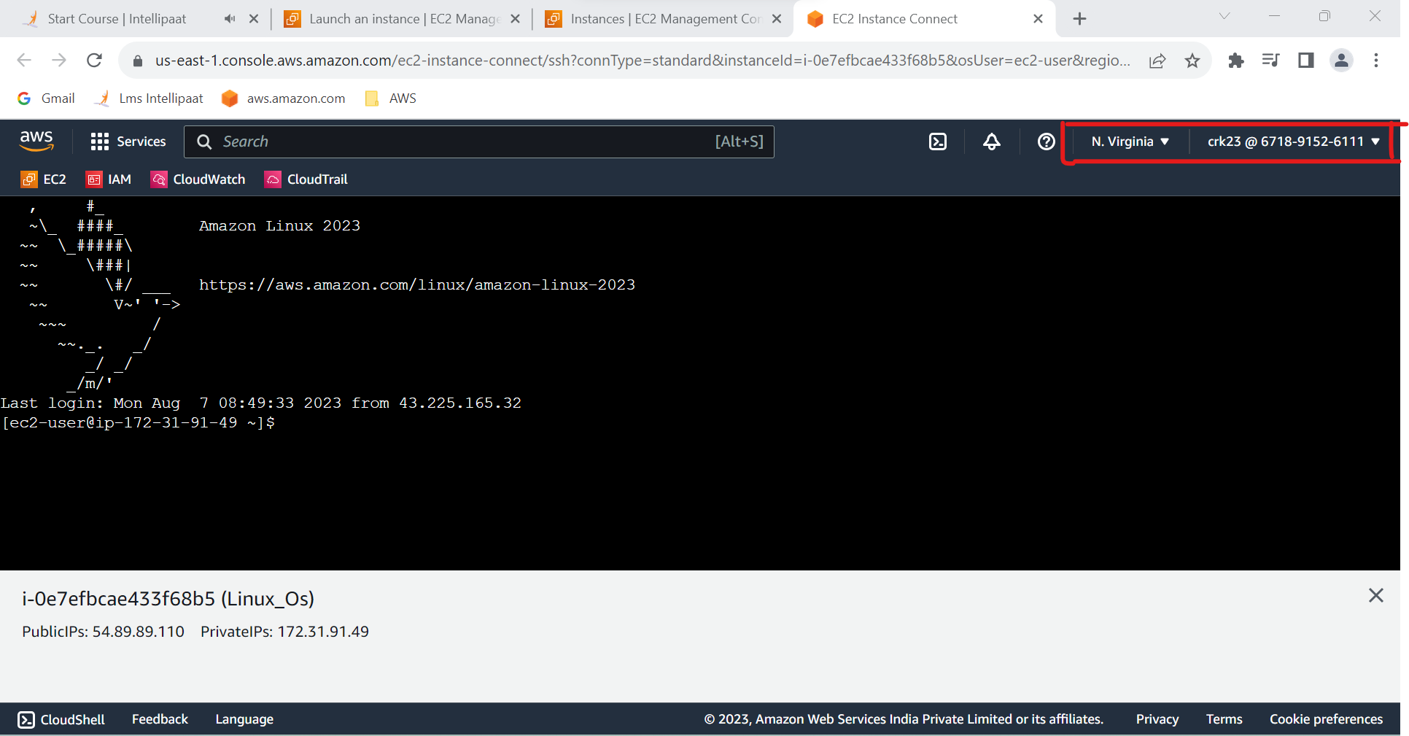

**Task 1 Output :**

Created an instance in the US-East-1 (N. Virginia) region with Linux OS and manage the requirement of web servers of your company using AMI.

**2.Replicate the instance in the US-West-2 (Oregon) region**.

**Step1** : Select the instance and go to Actions > Image & Templates > Create image

**Step 2** : Enter the name to be given . description is optional .

**Step 3** : click create image . Image created in AMI.

**Step 4** : In AMI , Select the AMI and go to actions > copy AMI

**Step 5** : In **Copy Amazon Machine Image (AMI)**  page give name and description and select destination region to US-West-2 (Oregon) region.

**Step 6** : Then click Copy AMI.

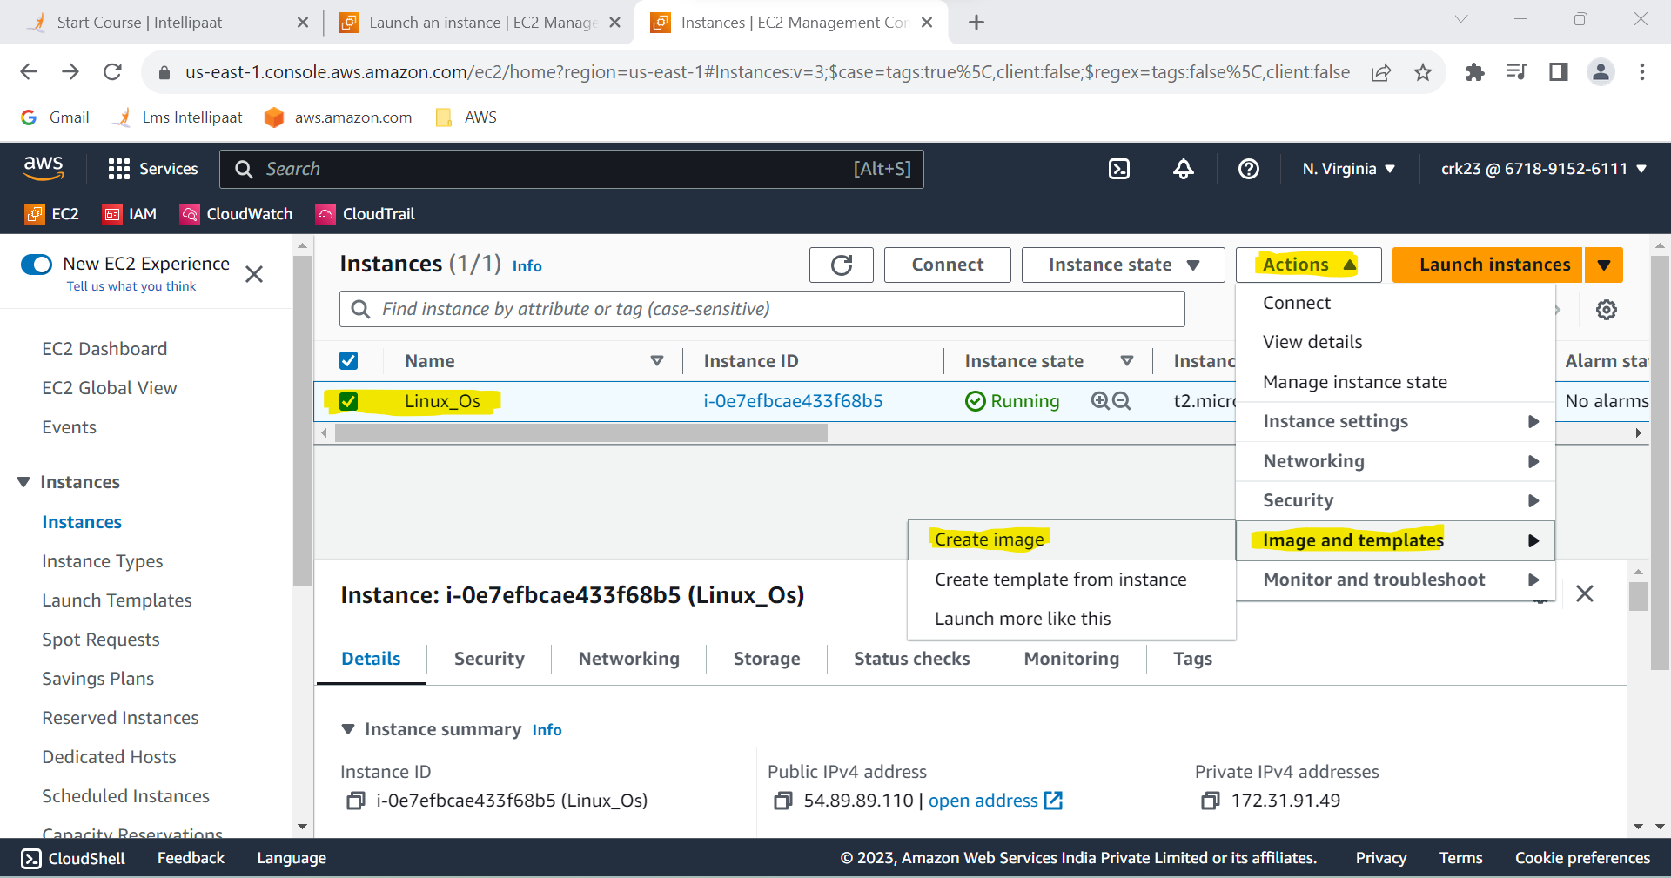

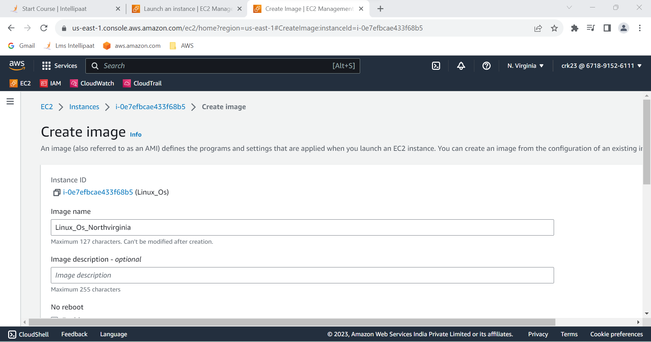

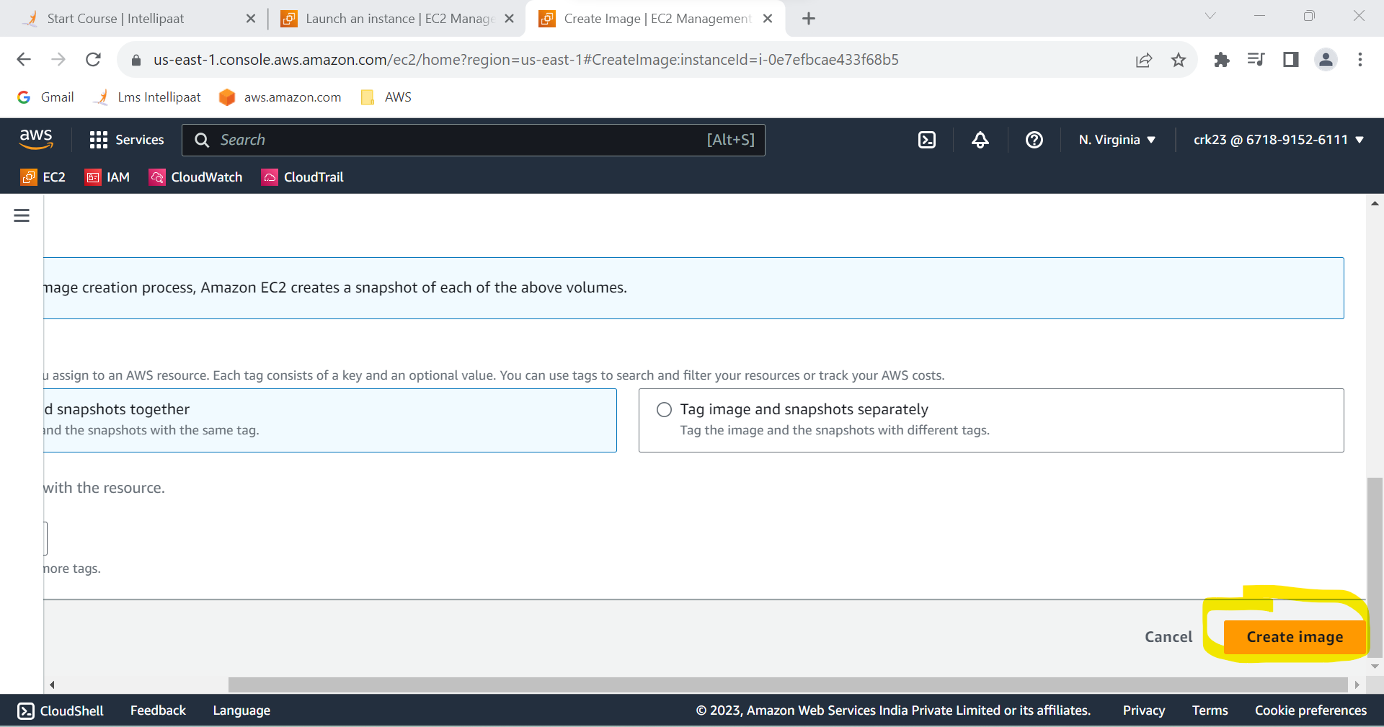

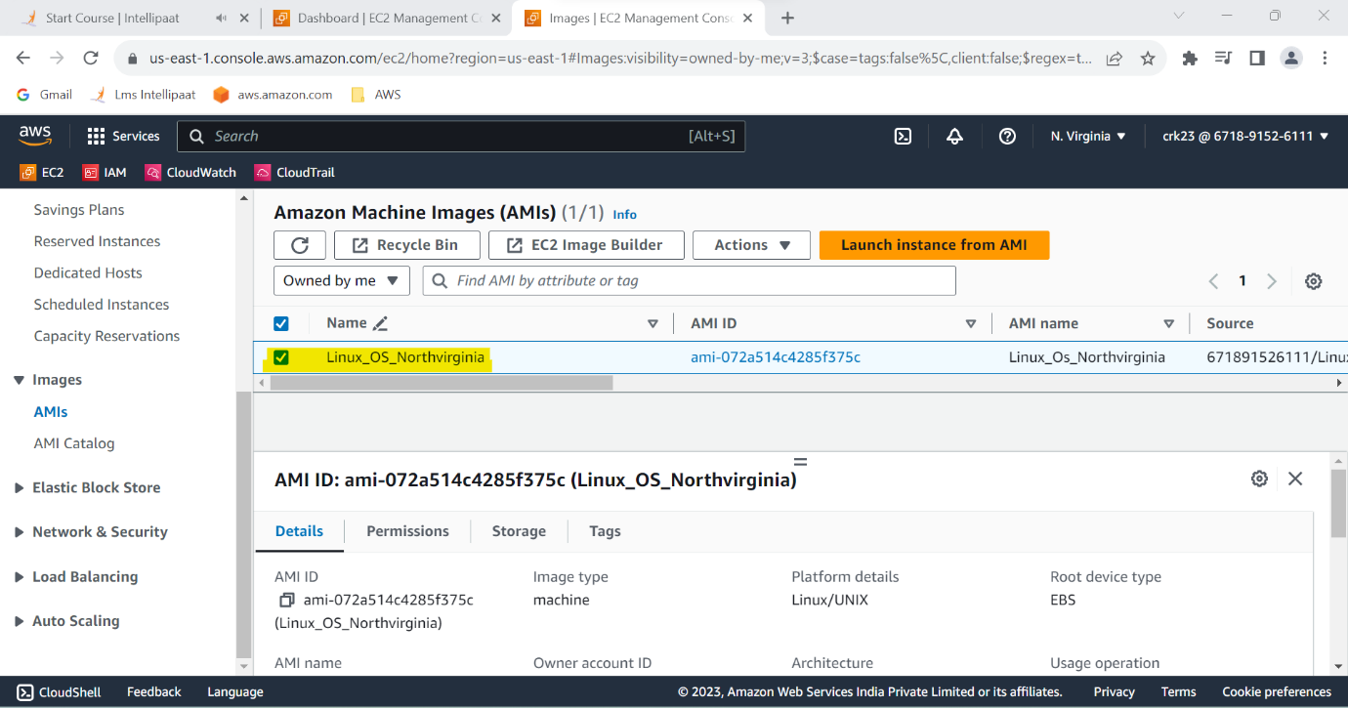

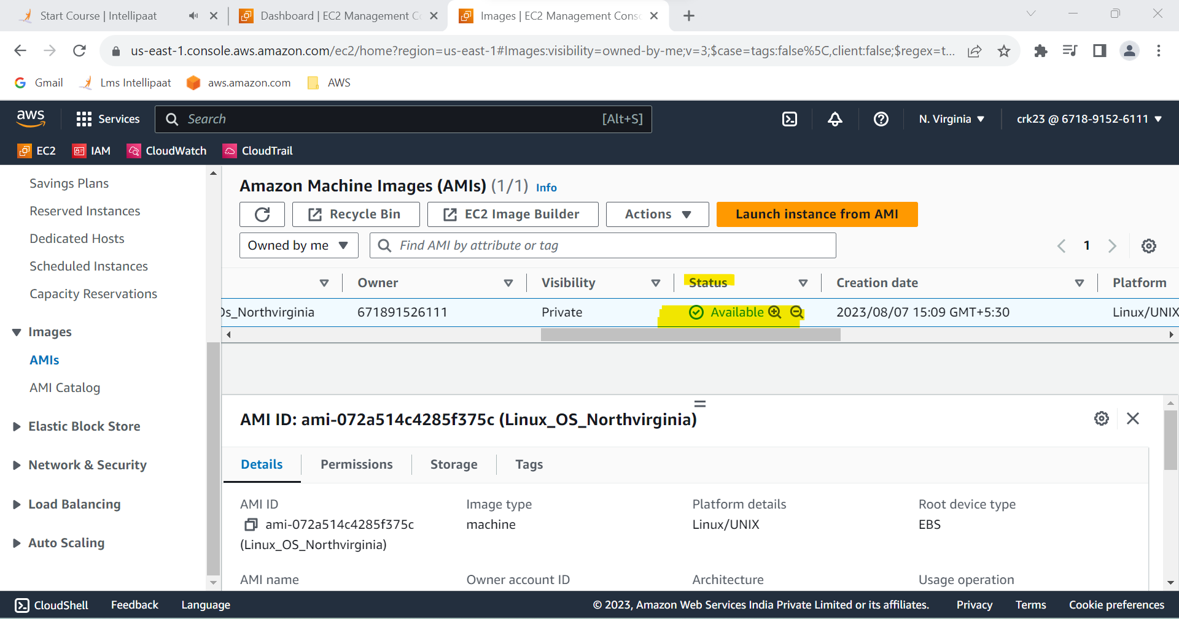

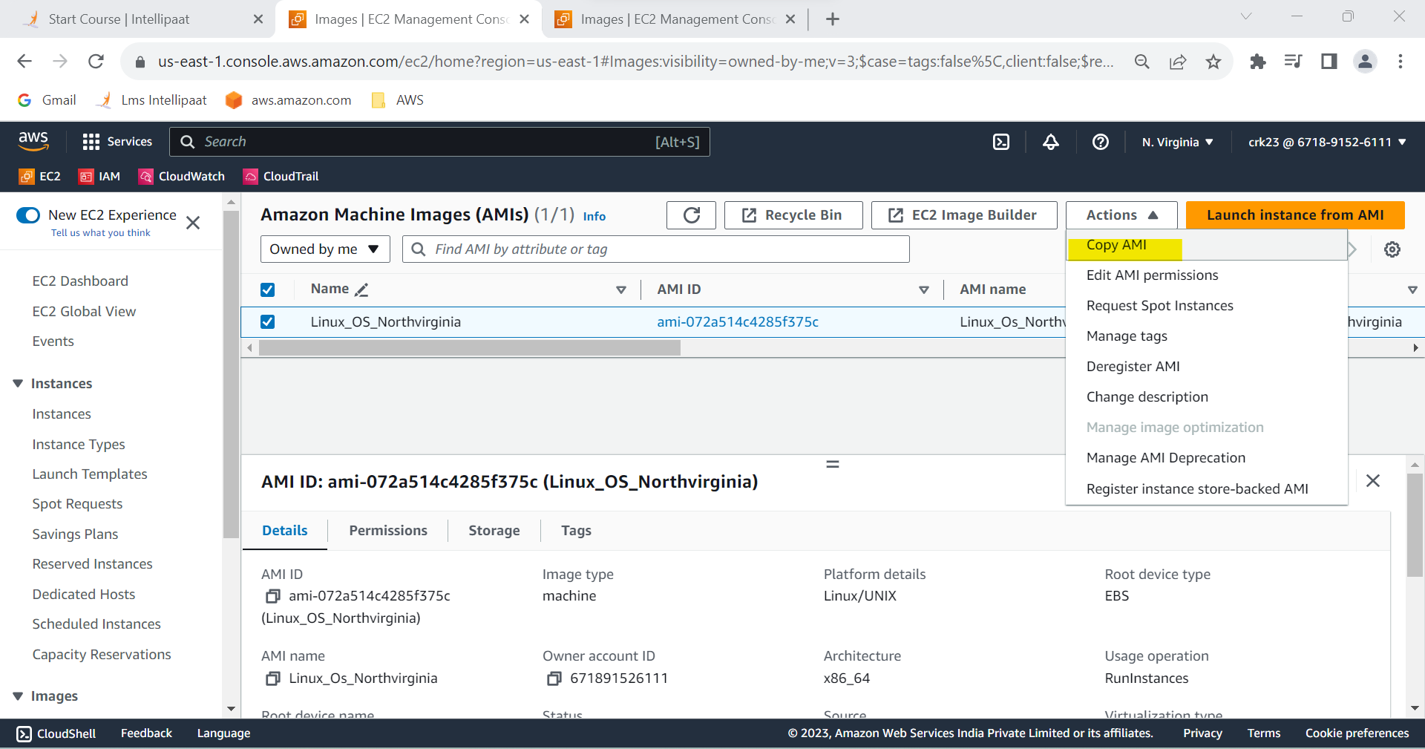

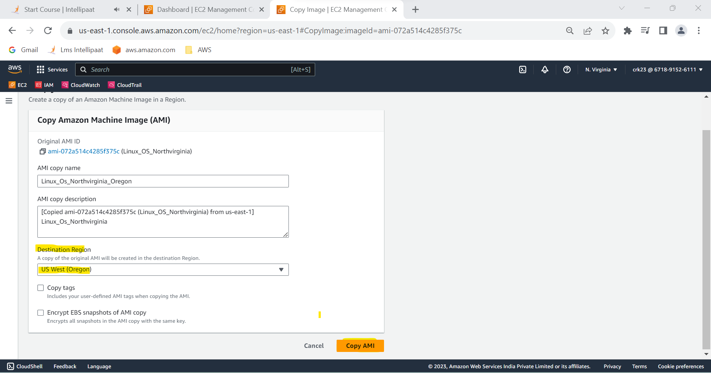

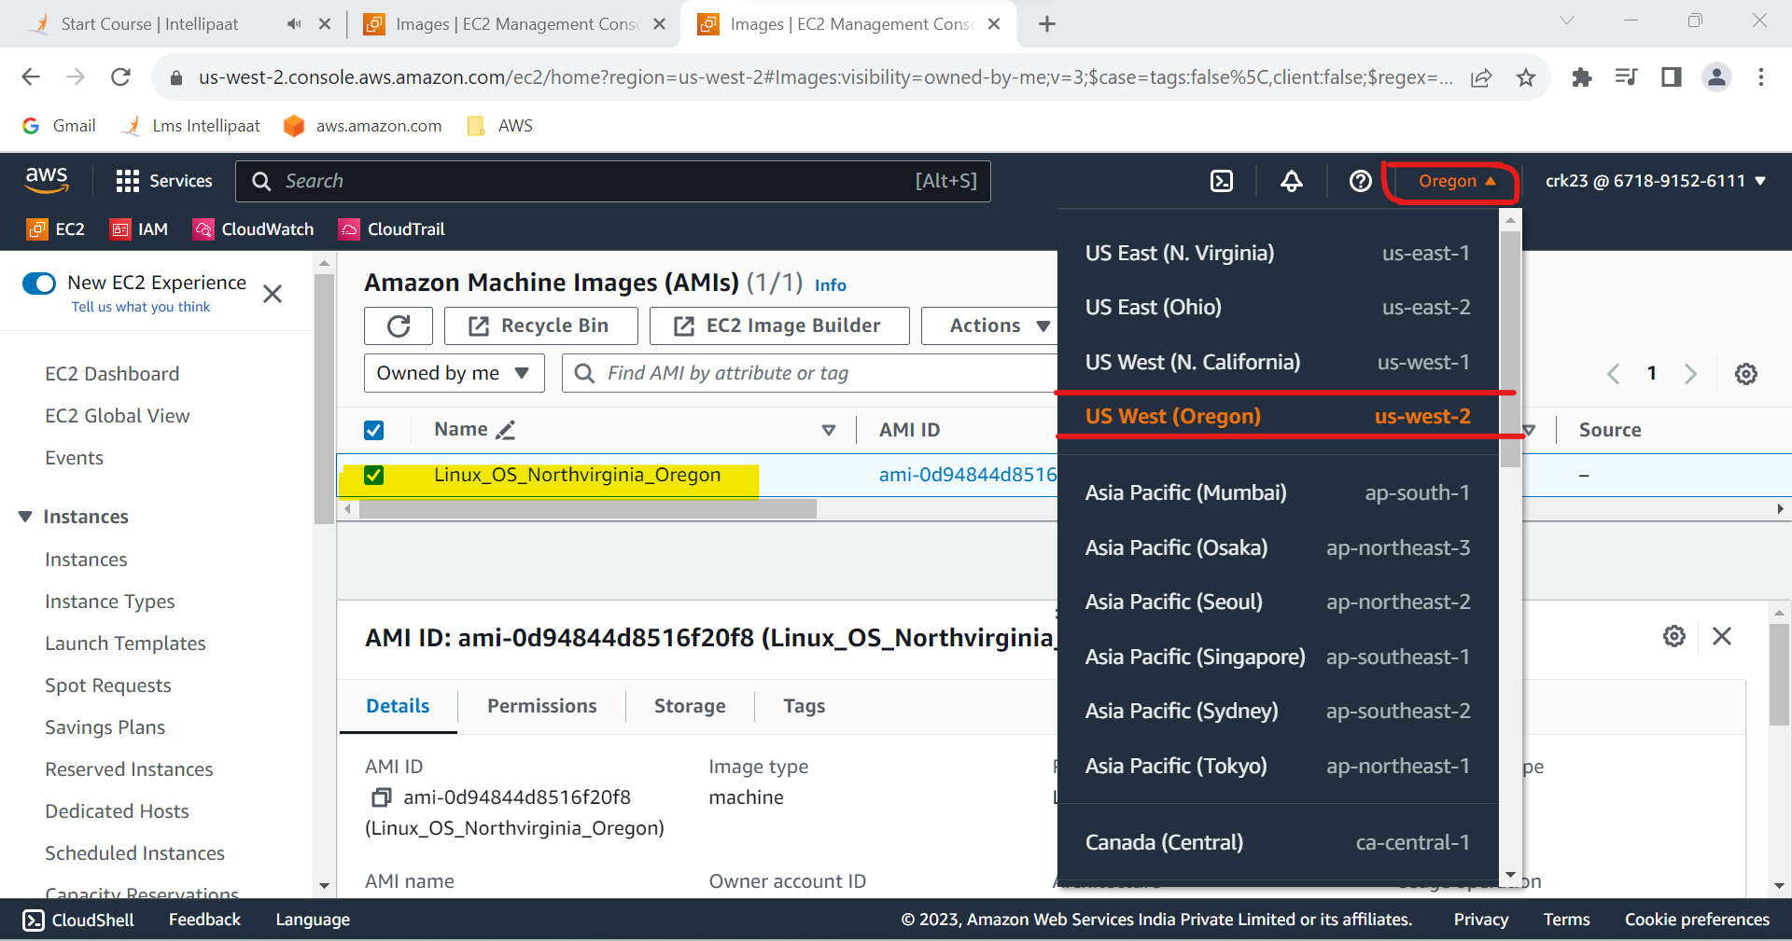

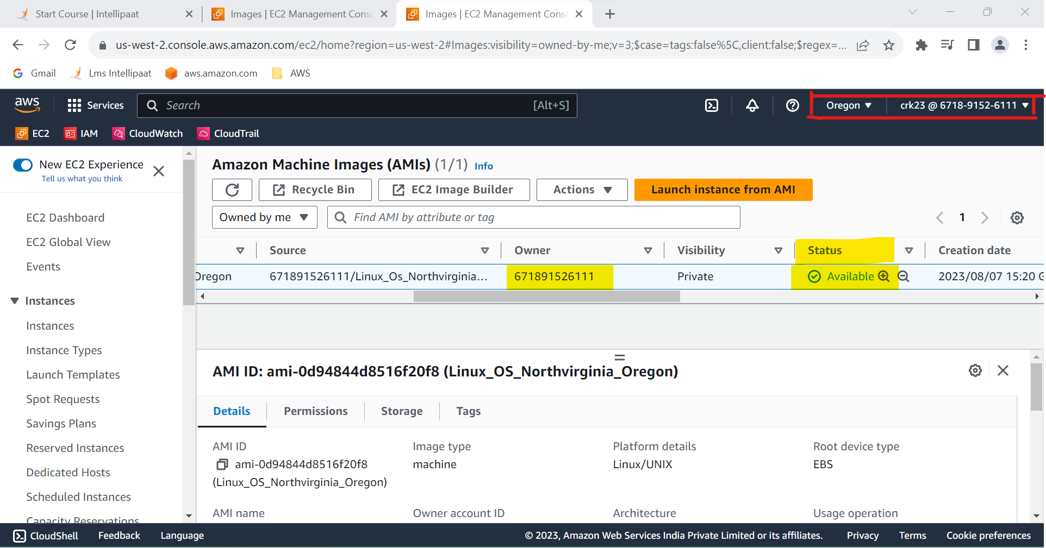

**Task 2 Output:**

Created replication the instance in the US-West-2 (Oregon) region.

**3.Build two EBS volumes and attach them to the instance in the US-East-1**

**(N. Virginia) region.**

**Step 1** : Select EBS > Volumes > Create Volume .

**Step 2** : select 1. volume type- general purpose2

2. Size – 5GiB

3. Availability Zone - US-East-1(N. Virginia) region.

*Same steps for creating another EBS volumes

-I have used 5 and 10 GiB volumes

**Step 3** : Click Create Volume

**Step 4** : Select volume 1 and then go to actions > attach volume

( Repeat step 4 for attaching volume 2 )

**Step 5** : In basic details page select the instance to which the volume is to be attached .

**Step 6** : Click attach Volume

**Step 7** : Go to instance and select the Linux_Os instance .In the storage tab Volume 1 & 2 is attached.

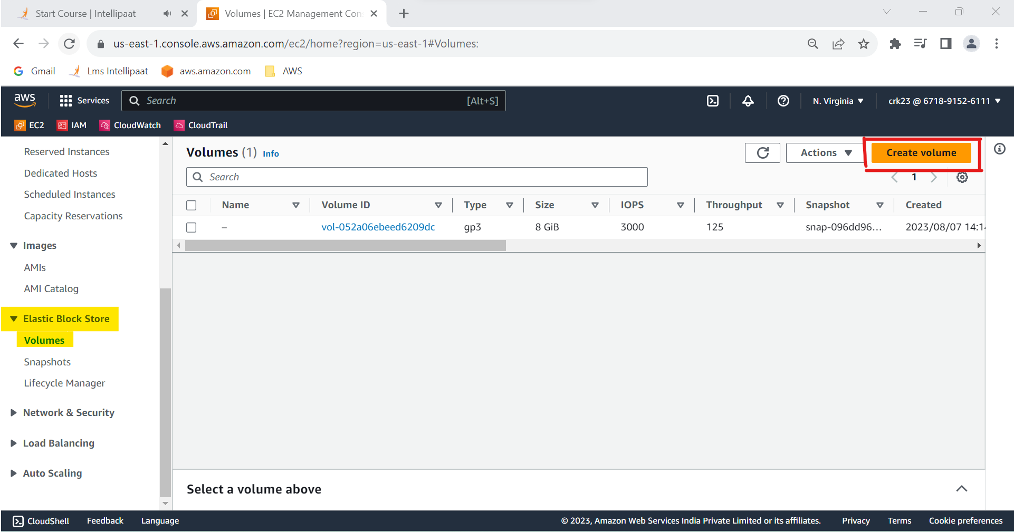

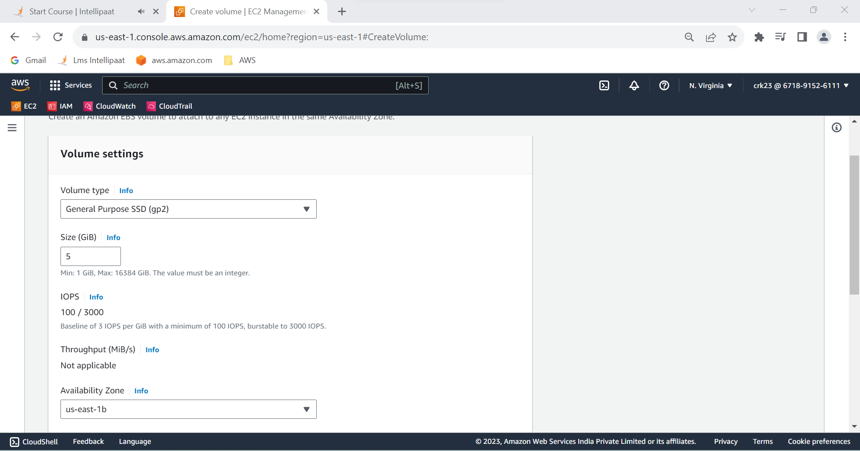

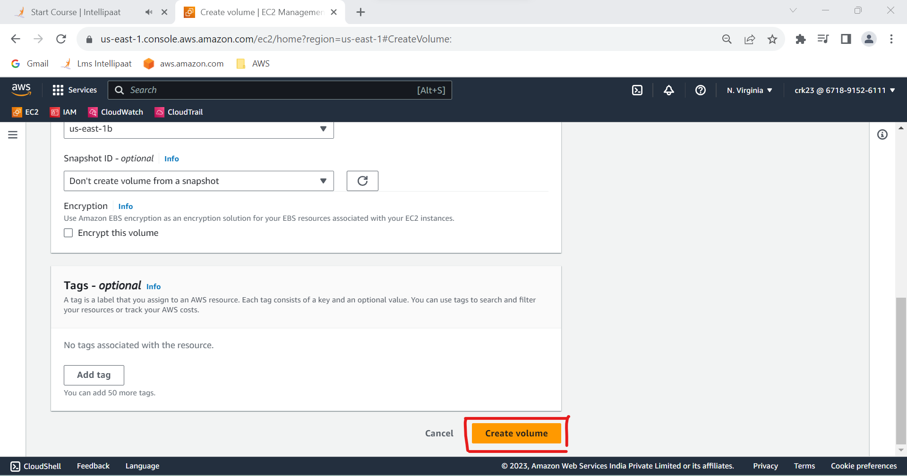

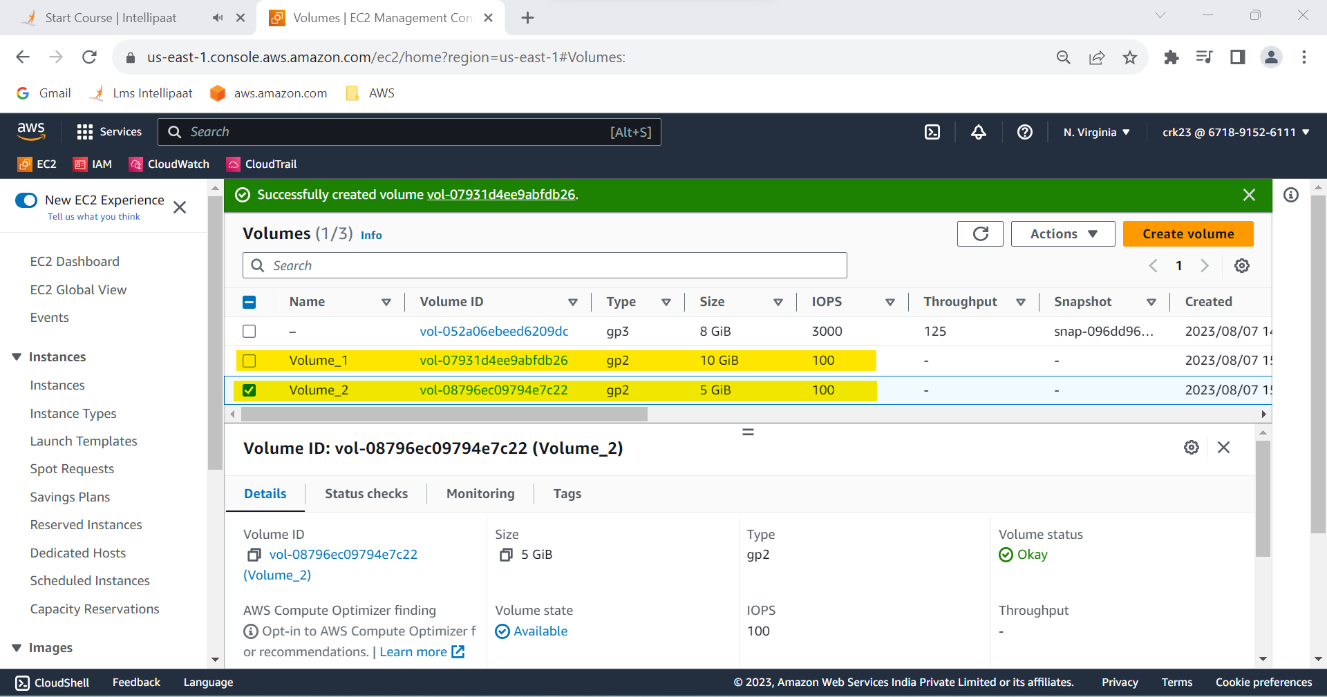

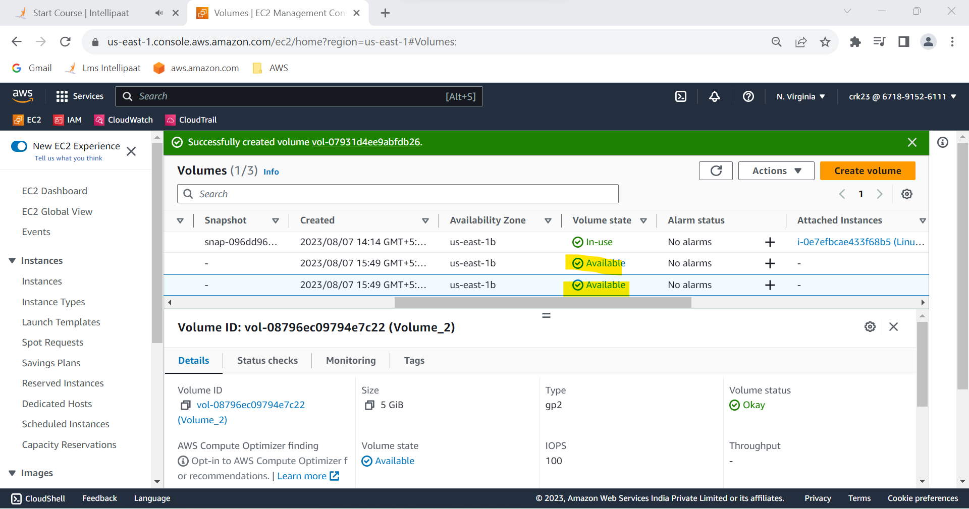

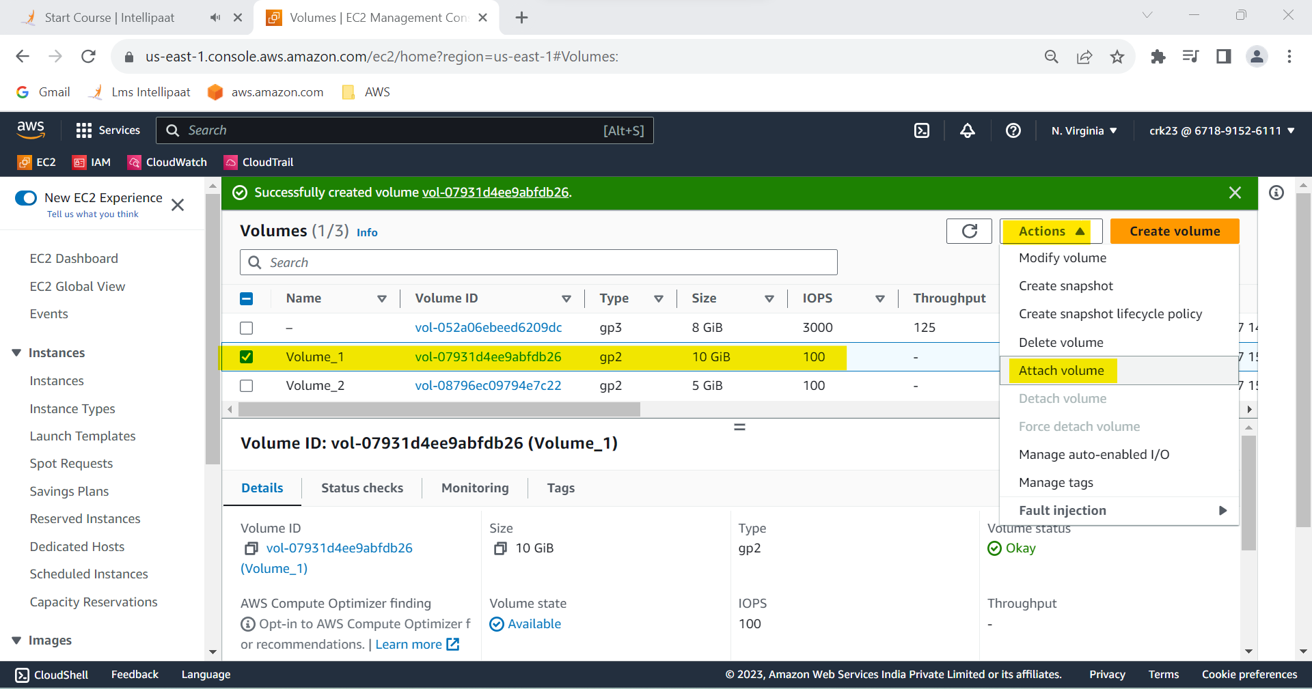

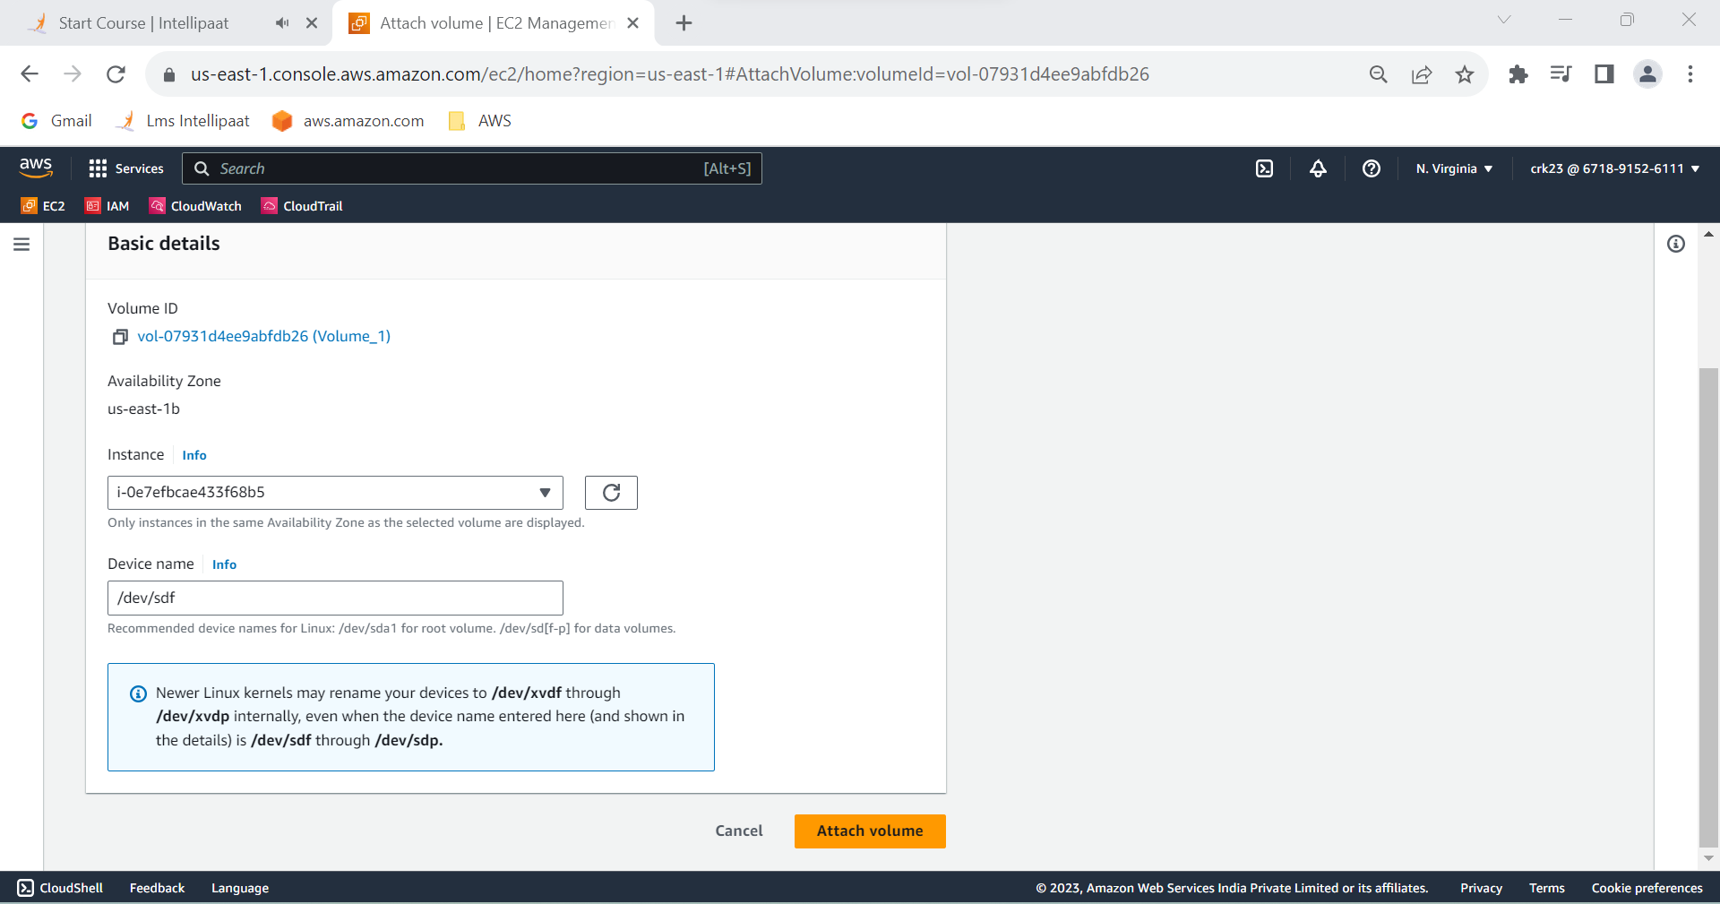

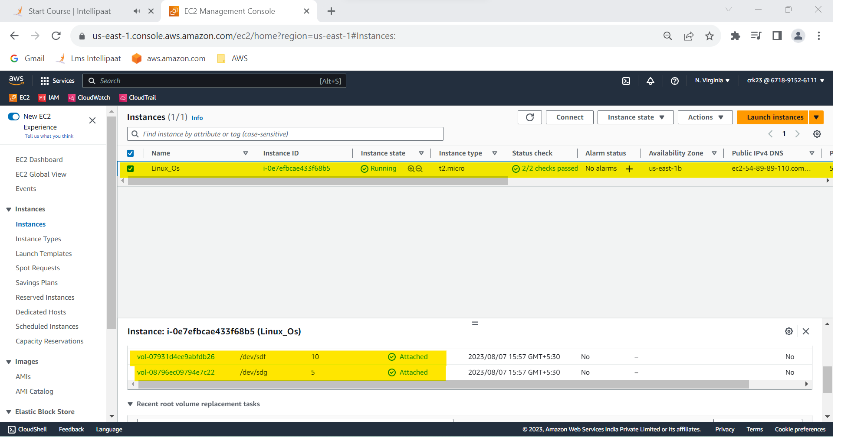

**Task 3 Output :**

Created two EBS volumes and attach them to the instance in the US-East-1(N. Virginia) region.

**4. Delete one volume after detaching it and extend the size of the other**

**volume.**

**Step 1** : Select the EBS volume(Volume 1) to be detached

Volume 1 - 10 GiB

Volume 2 - 5 GiB

**Step 2** : Actions > Detach volume (Volume 1 have been detached)

**Step 3** : Check the instance if Volume have been detached

**Step 4** : Select the Volume 1 and go to Actions > Delete volume . Volume 1 has been deleted

**Step 5**: Select the Volume 2 and go actions > modify volume

**Step 7** : In the volume details page I have increased the volume to 7 GiB.Now the Volume2 is increased to 7 GiB.

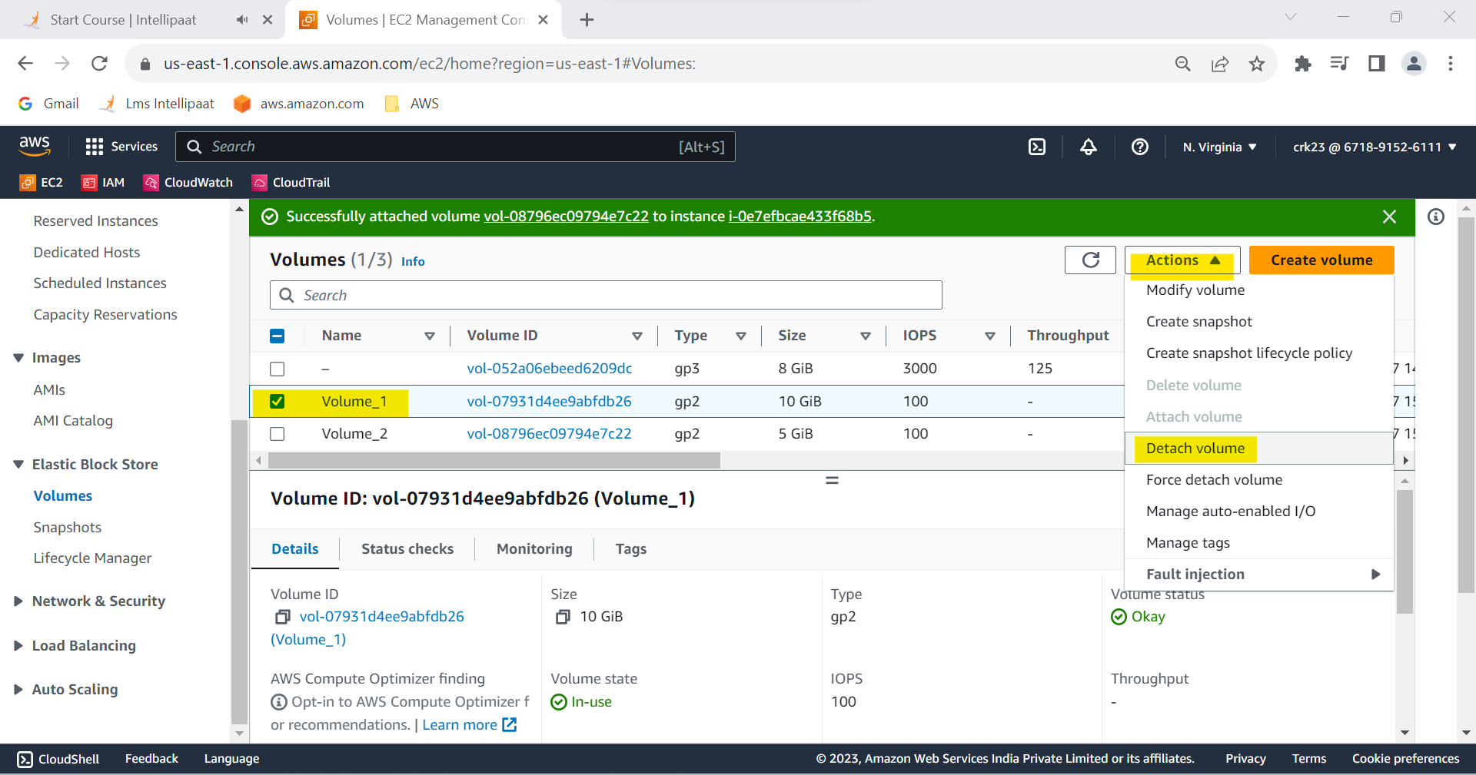

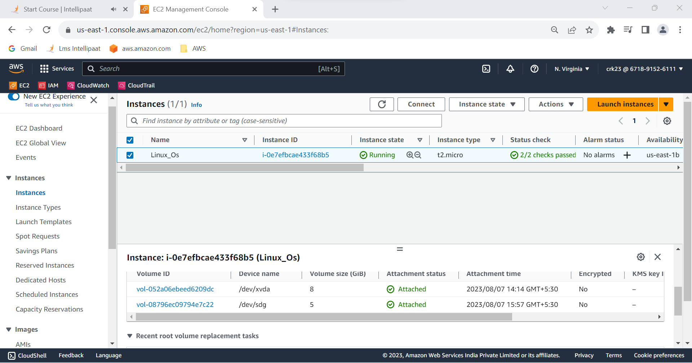

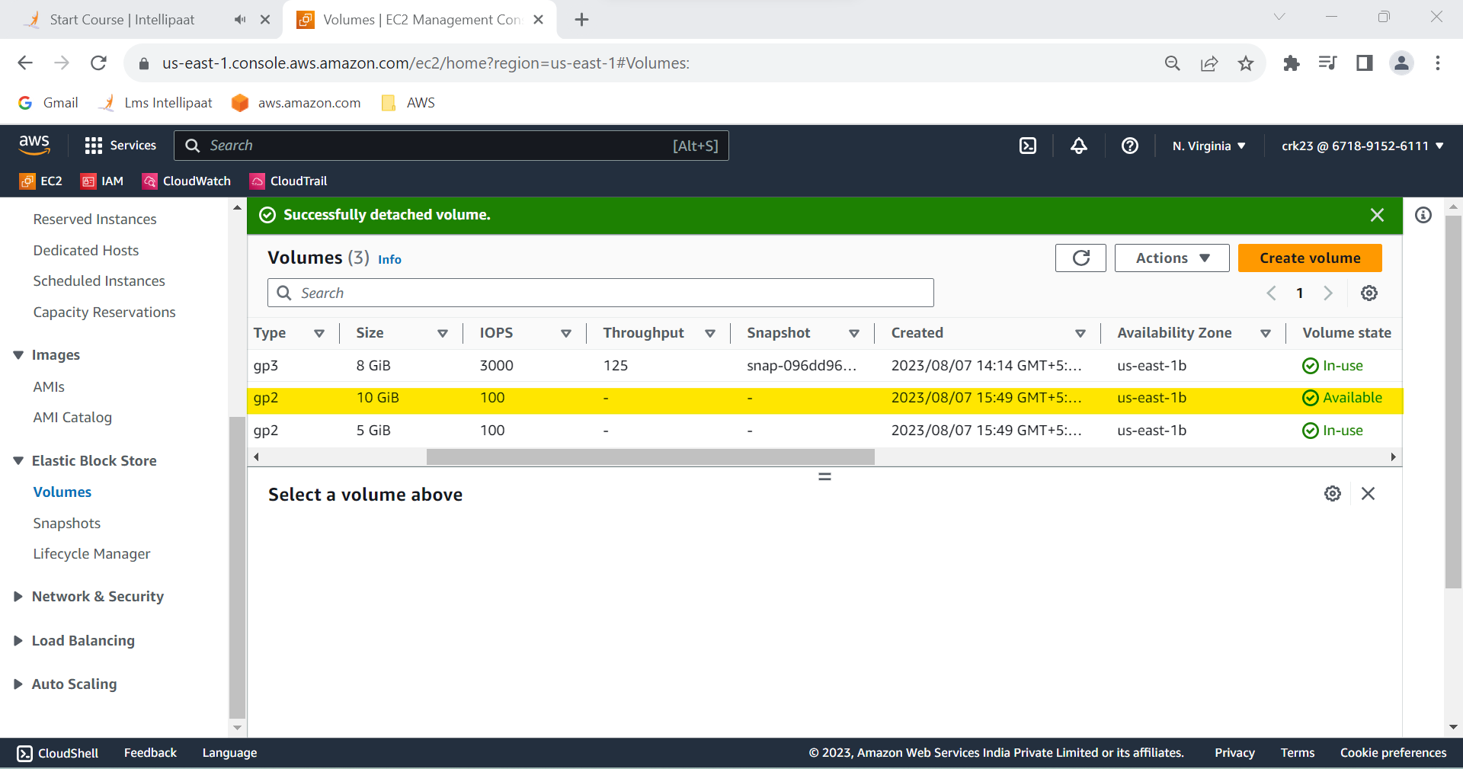

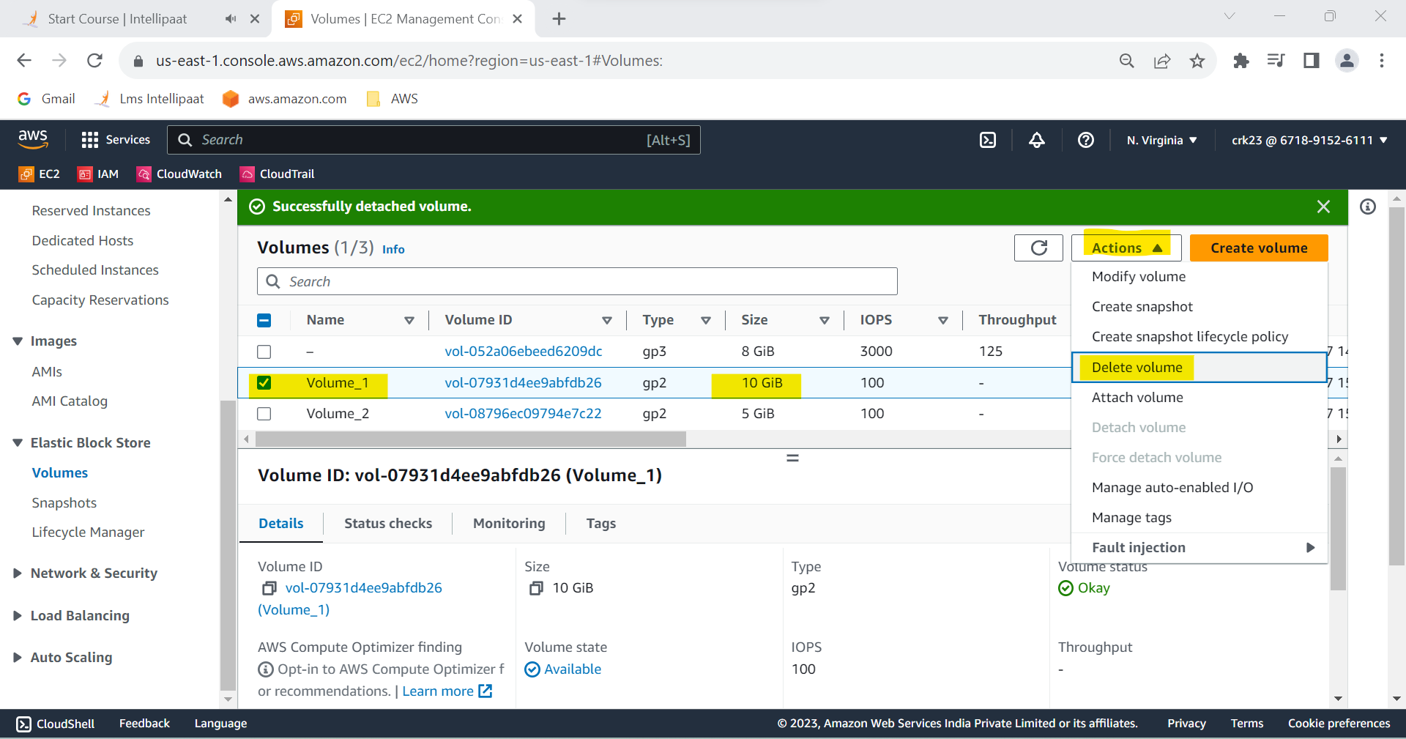

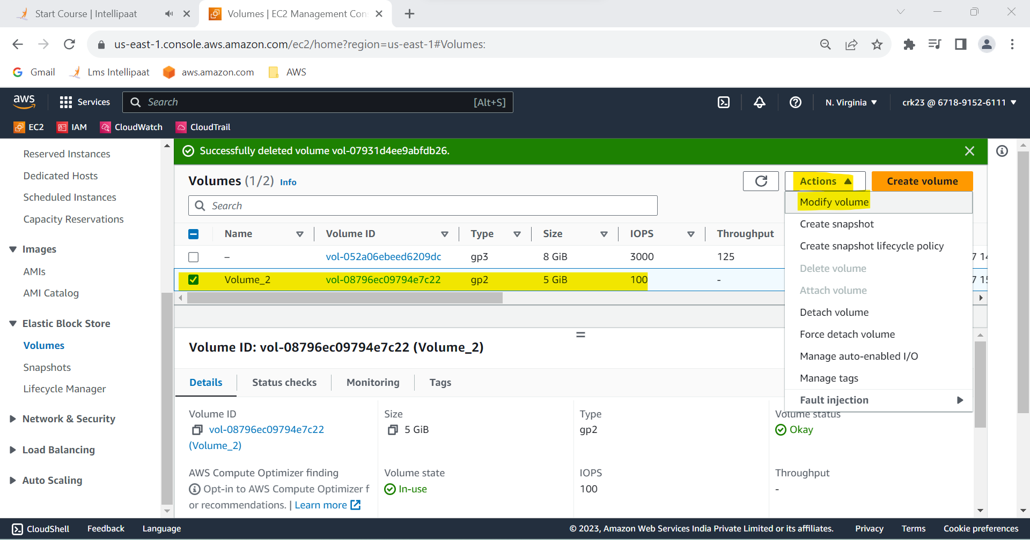

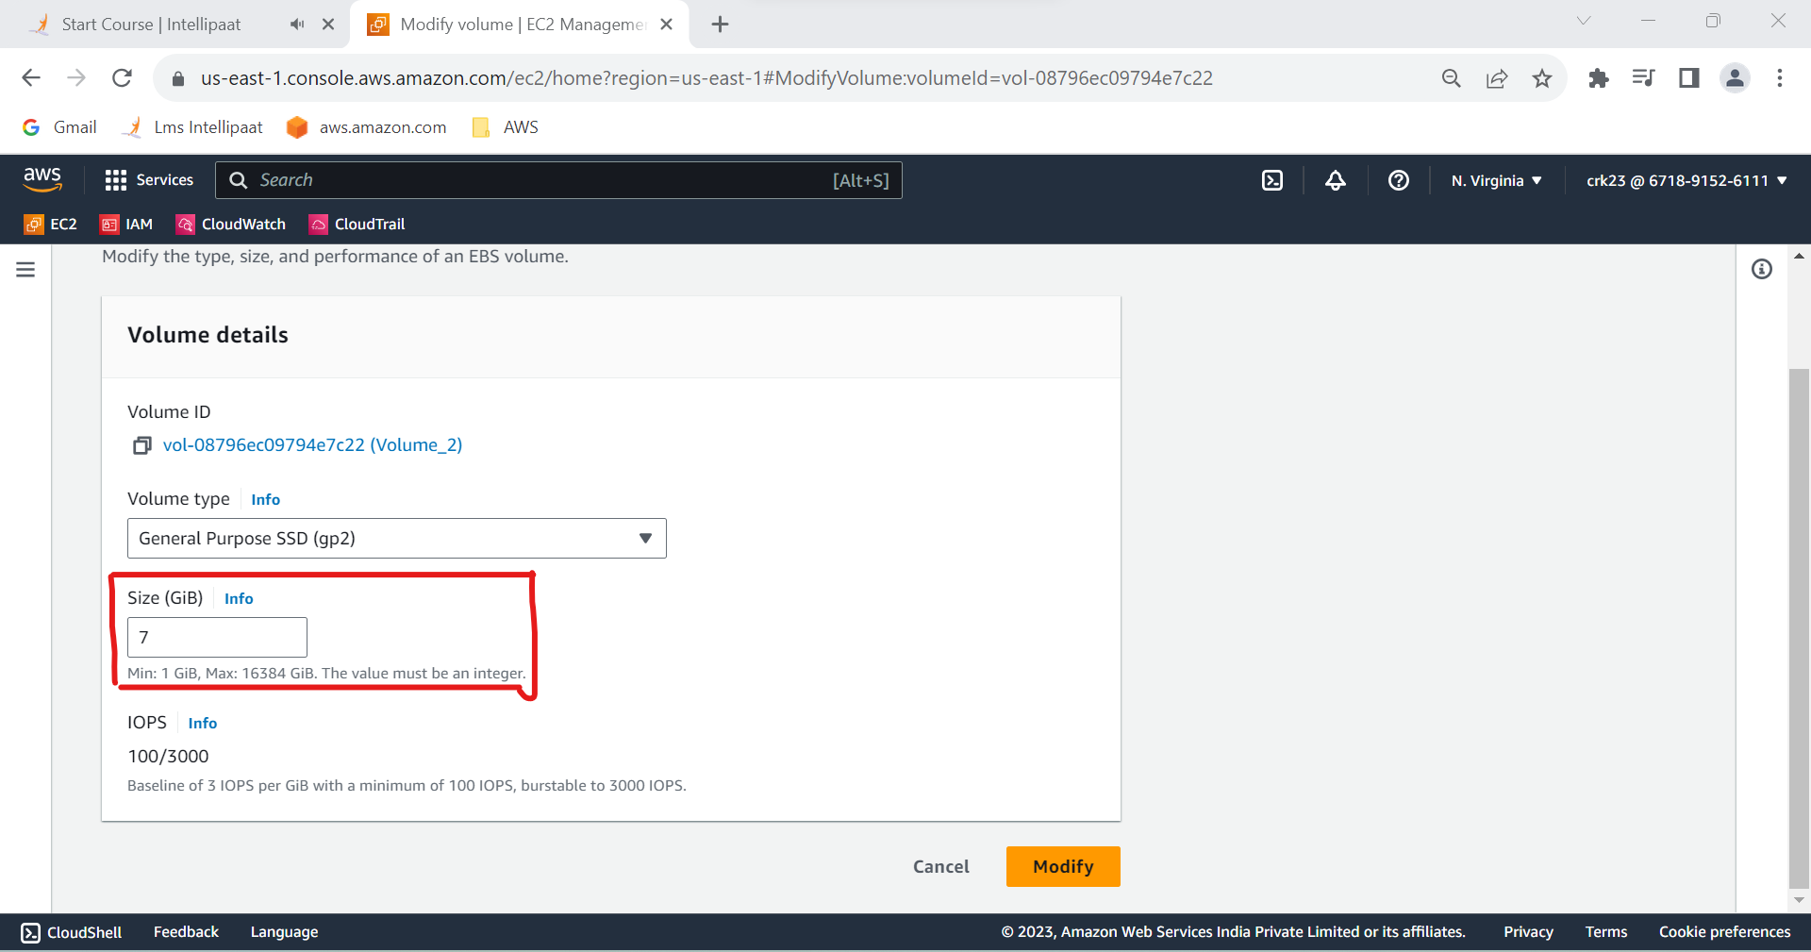

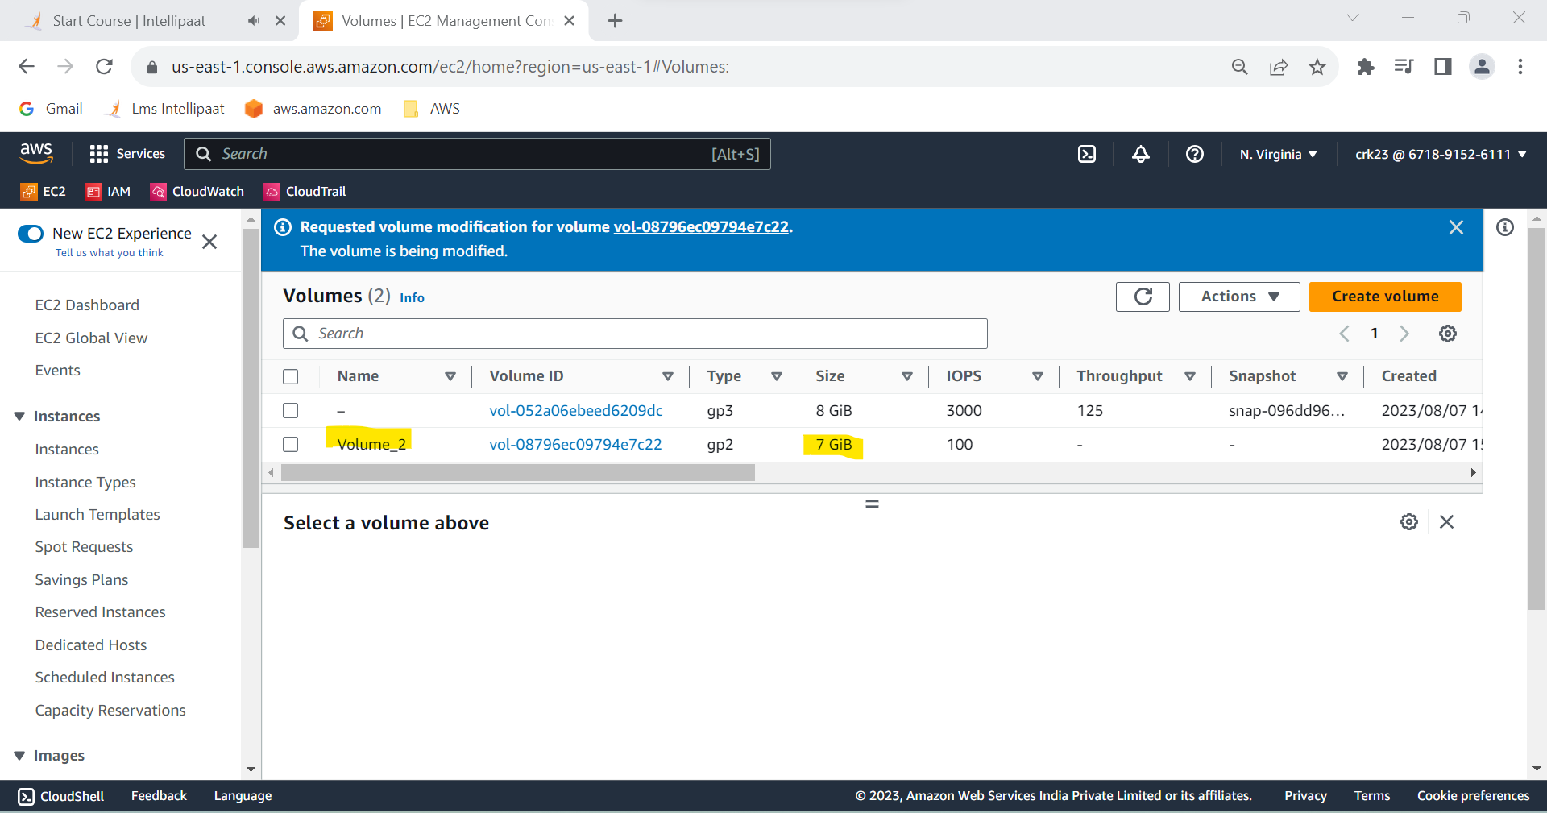

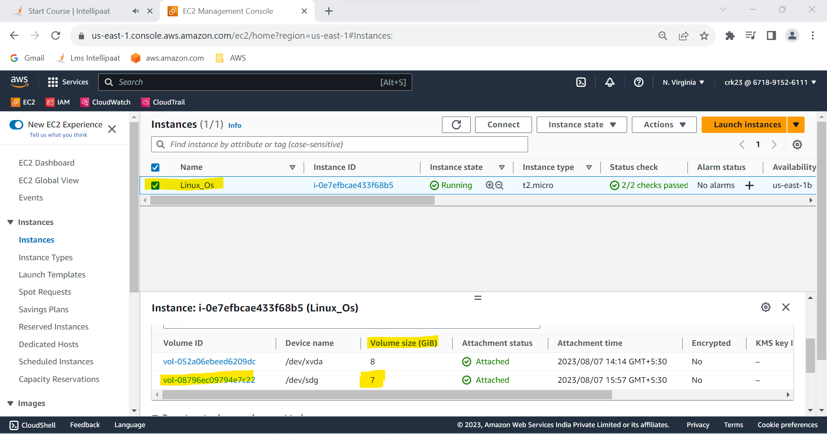

**Task 4 Output :**

Compeletd Delete one volume after detaching it and extend the size of the other volume**.**

**5.Take backup of this EBS volume**

**Step 1:** Select the Volume 2 and go to Actions > create snapshot

**Step 2**: In the create snapshot page give the description of the snapshot

**Step 3** : Click create snapshot ( snapshot is created )

**Step 4** : Go to snapshots and check snapshot is created .

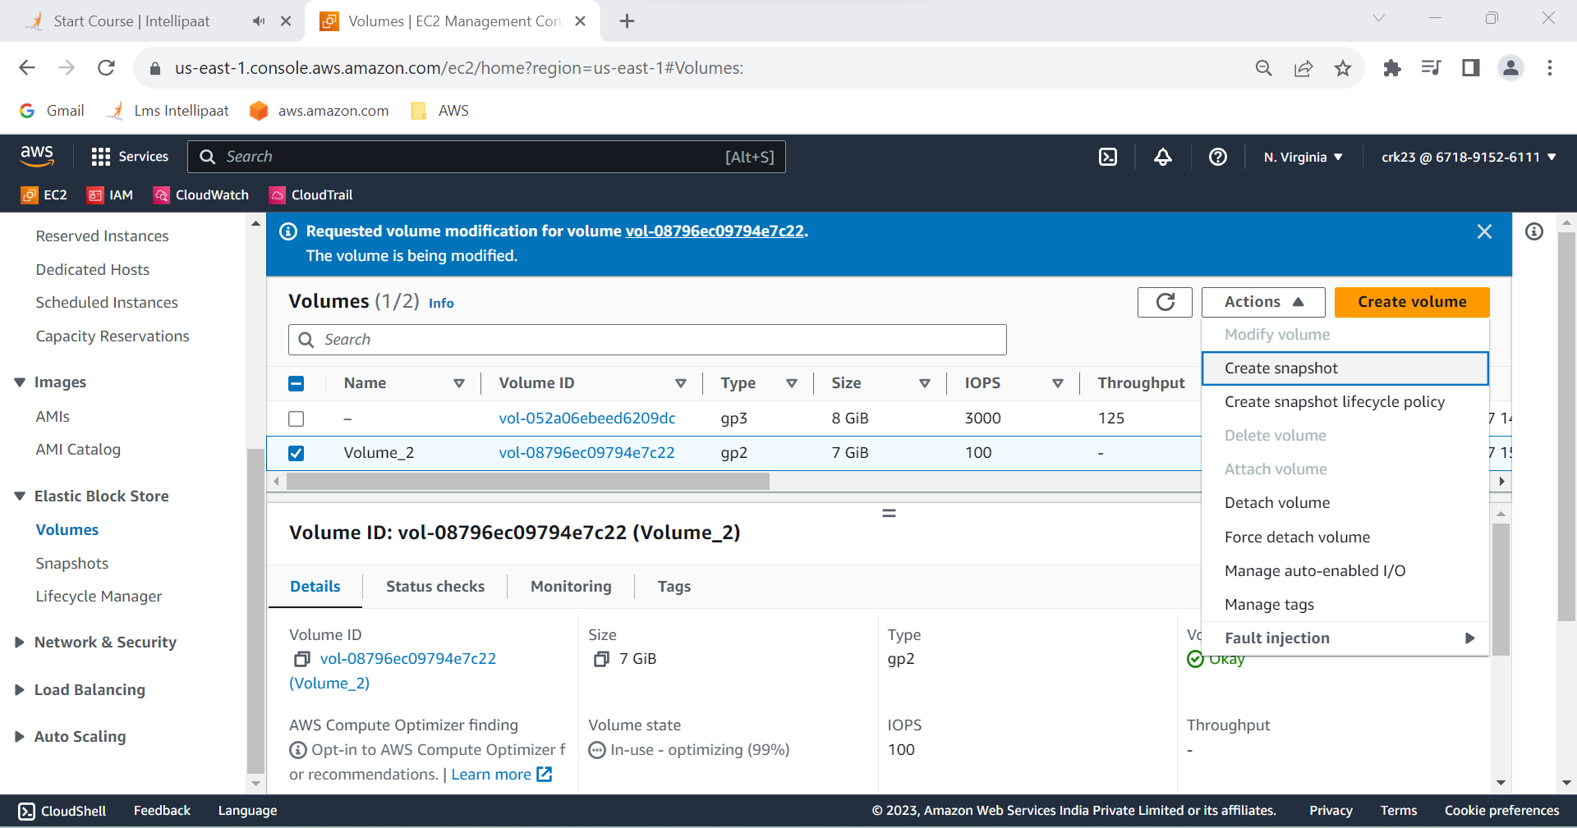

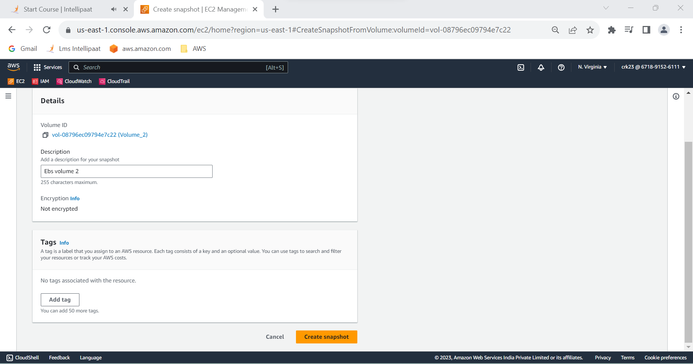

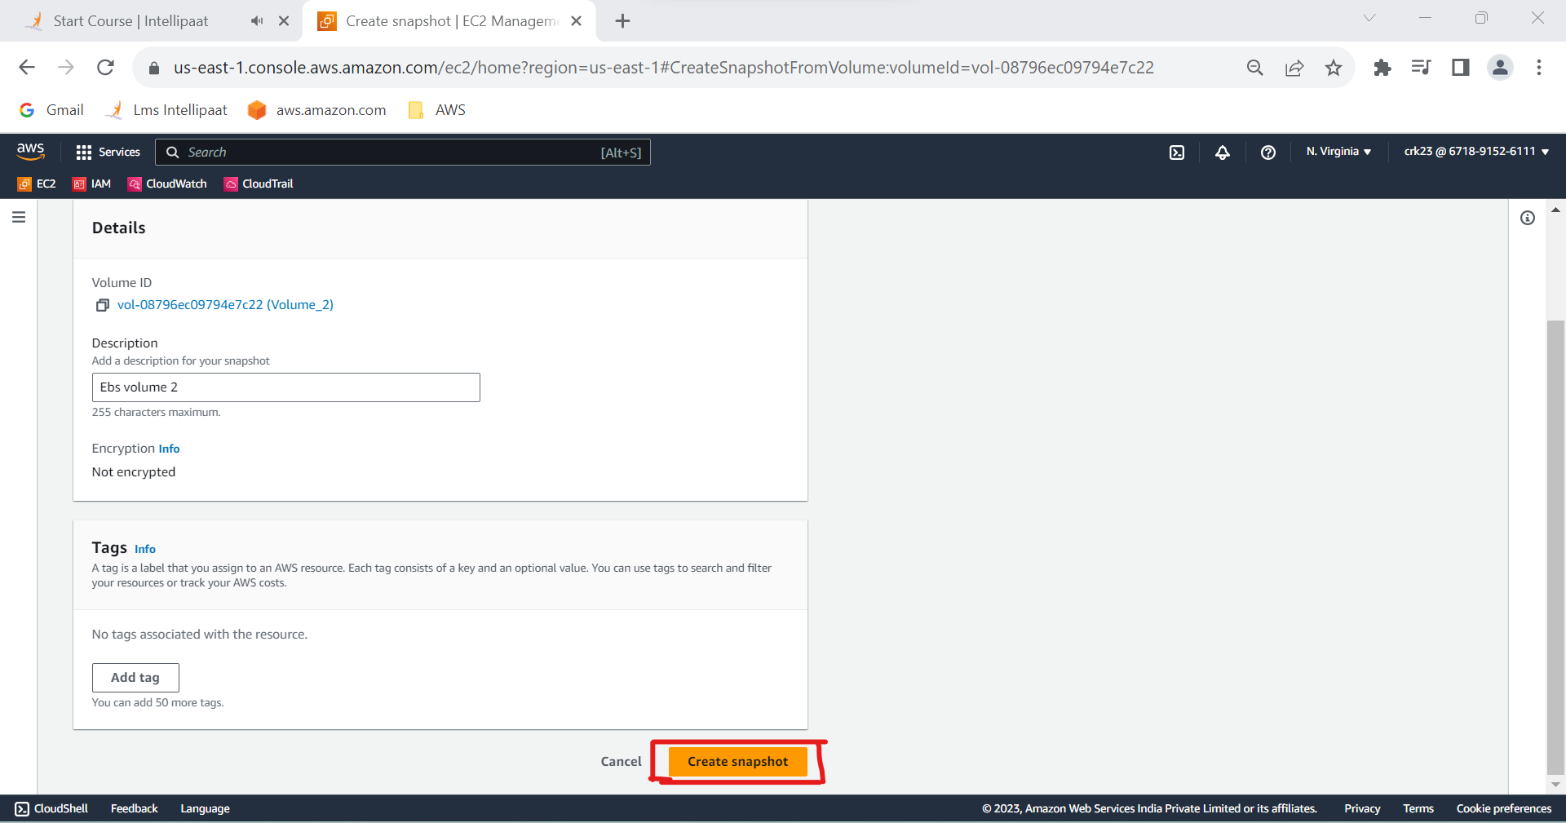

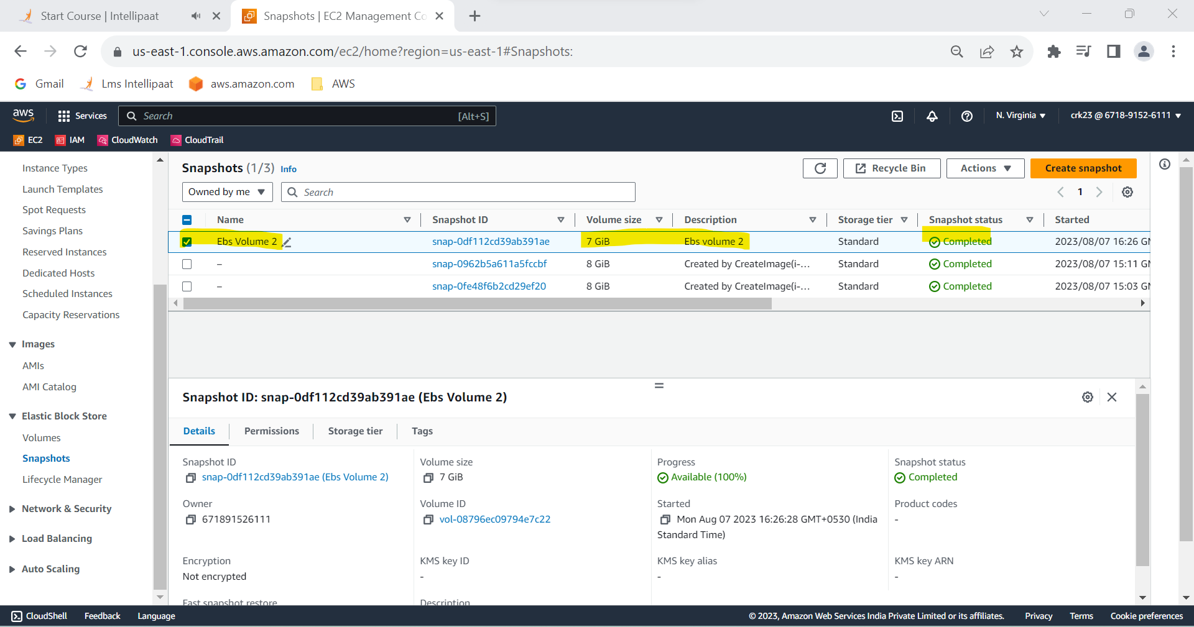

**Task 5 :**

Compeleted backup of Volume 2 EBS volume.